

**Final Year B. Tech (EE)**

**Semester: I**

**Subject:**

**Artificial Intelligence and Machine Learning**

**Name: Siddharth Bhagwat**

**Roll No: 53**

**Class: TY B.Tech**

**Batch: A3**

**Experiment No: 08**

**Name of the Experiment**: **Implement** FIS with Mamdani Interfacing Mechanism Functions



**Marks** **Teacher’s Signature with date**

**Performed on:**

**Submitted on:**



**Aim:** To implement FIS with mamdani inferencing mechanism using

MATLAB/Python code.

**Prerequisite:** Knowledge of fuzzy sets, membership functions.

**Objective:**

To implement various fuzzy membership functions using Python code.

**Components and Equipment required:**

Python software, NumPy and Panda Libraries, MATLAB with Fuzzy toolbox

|  |  |  |  |  |  |
| --- | --- | --- | --- | --- | --- |
|  | | |  | **Expt7- 1** | |
|  |  |  |  |  |  |
|  |  |  |  |  |  |
|  |  |  | **WWW.MITWPU.COM** | | |



**Theory:**

The Mamdani fuzzy inference system is proposed as a first attempt to control a food quality and service by a set of linguistic control rules. To use fuzzy toolbox to model tips value that is given after a dinner based on quality of food (poor, average or good) and service (poor, average or good) and the tip value is decided accordingly in the range from 0 to 25 % of bill value.

As an illustration model we would consider an example in which two input linguistic variables Quality of food and Service provided are considered with poor, average or good membership functions.

# Procedure:

**INPUTS:**

Quality**:** {Poor, Average, Good}

Service: {Poor, Average, Good}

# OUTPUT:

Tips**:** Tip value ranging from 0-25 % of bill amount

# Use Fuzzy Inference System (FIS) Editor and perform the following

1. Go to command window in Matlab and type fuzzy.
2. New Fuzzy Logic Designer window will be opened.
3. Give Input / Output Variable.
   1. Go to Edit Window and click Add variable
   2. As per our requirements create two input variables namely quality and service Quality**:** {Poor, Average, Good}

Service: {Poor, Average, Good}

* 1. Similarly, one output variable as tip value ranges from 0 to 25%.

1. The values for Quality and Service variables are selected for their respective ranges.



1. Quality:
   1. Double click the Quality input variable.
   2. New window will be opened and remove all the Membership Functions.
   3. Go to Edit and Click Add MFs and select the 4 Parameters for Quality table.

Change the following fields as per the table given below.

|  |  |  |
| --- | --- | --- |
| MF1:  Range: [0 1 10] Name: Poor  Type: trapmf Parameter [0 0 2  5] | MF2:  Range: [0 1 10] Name: Average  Type: trimf  Parameter [2 5 10] | MF3:  Range: [0 1 10] Name: Good Type: trapmf  Parameter [5 7 10 10] |

6. Similarly add the data to service and tips variables.

7. Go to Rules: Edit → Rules

8. Add the Rules

9. Go to view → Rules

10. Exit

# Sample Input and Output:

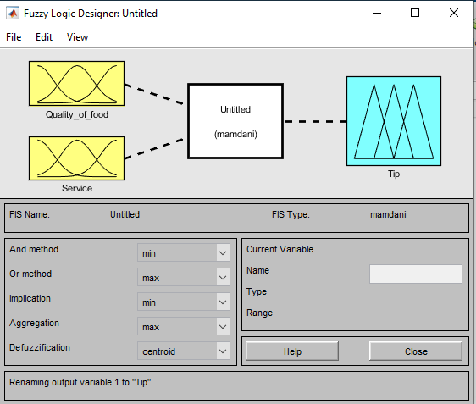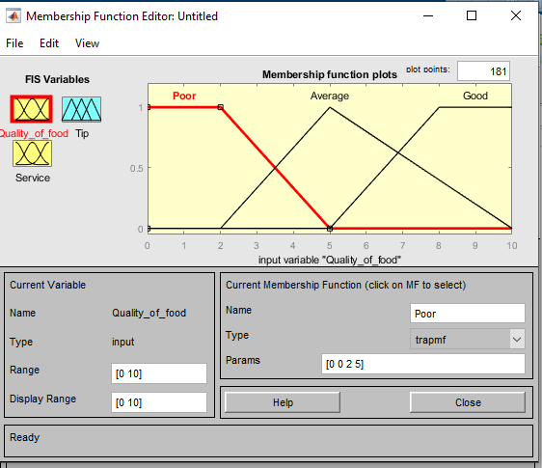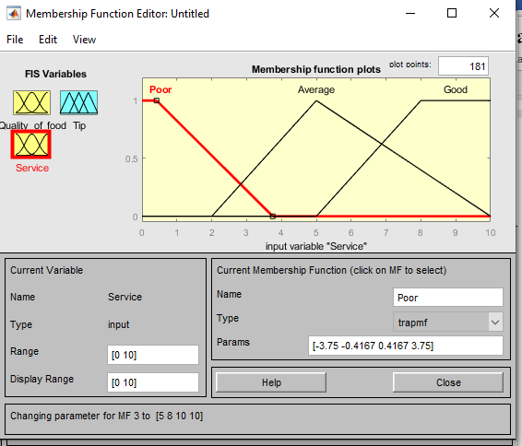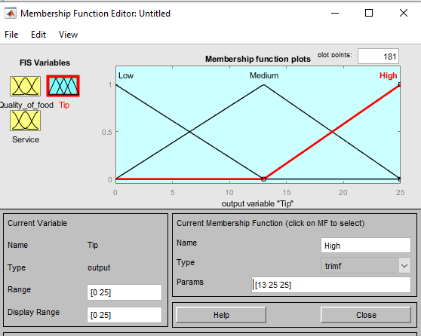

**Created Rules:**

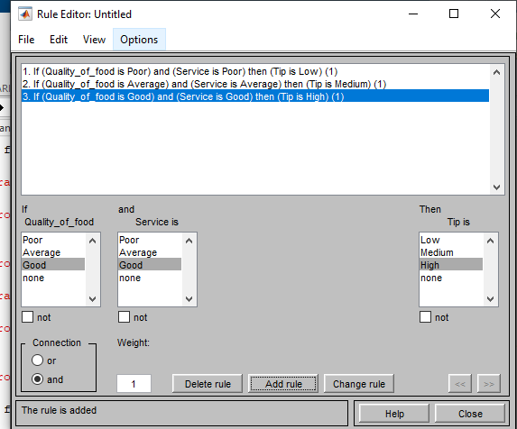

**Output Obtained:**

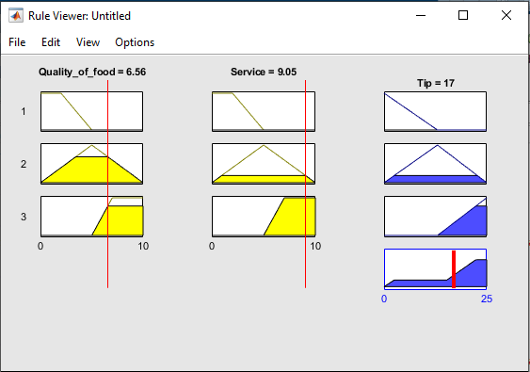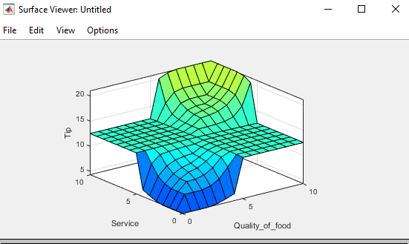

Python Code:

import numpy as np

import skfuzzy as fuzz

from skfuzzy import control as ctrl

**quality = ctrl.Antecedent (np.arange(0, 11, 1), 'quality')**

**service = ctrl.Antecedent (np.arange(0, 11, 1), 'service')**

**tip = ctrl.Consequent (np.arange(0, 26, 1), 'tip'**

**service.automf()**

**quality.automf(3)**

**tip ['low'] = fuzz.trimf(tip.universe, [0, 0, 13])**

**tip ['medium'] = fuzz.trimf(tip.universe, [0, 13, 25])**

**tip ['high'] = fuzz.trimf(tip.universe, [13, 25, 25])**

**quality['average'].view()**

**service.view()**

**tip.view()**

**rule1 = ctrl.Rule(quality['poor'] & service['poor'], tip['low'])**

**rule1.view()**

**rule2 = ctrl.Rule(quality['average'] & service['average'], tip['medium'])**

**rule3 = ctrl.Rule(quality['good'] & service['good'], tip['high'])**

**tipping_ctrl = ctrl.ControlSystem([rule1, rule2, rule3])**

**tipping = ctrl.ControlSystemSimulation(tipping_ctrl)**

**tipping.input['quality'] = 8.5**

**tipping.input['service'] = 9.5**

**tipping.compute()**

**print(tipping.output['tip'])**

**tip.view(sim=tipping)**



**Conclusion:**

**Post Lab Questions:**

1. Define fuzzy set and crisp set.
2. What are the various operations on fuzzy set?
3. What are the set operations which are violated in fuzzy set theory?
4. Explain FIS in detail.